**Subject:** DBMSL **Class:** SE B

**Mini Project Synopsis**

**Group Id:- 10**

**Group Members:-**

|  |  |  |  |
| --- | --- | --- | --- |
| **Roll**  **No.** | **Name** | **Mobile** | **Email** |
| 27019 | Shivam Ghaware | 9146639504 | shivam_ghaware_it@moderncoe.edu.in |
| 27032 | Sahil Karamkar | 9021550634 | karamkarsahil14@gmail.com |
| 27006 | Yash Bhombe | 7058386951 | yash_bhombe_it@moderncoe.edu.in |
| 27036 | Nilesh Khude | 8983464580 | nilesh_khude_it@moderncoe.edu.in |

**Project Title: Electricity Billing System**

**Problem statement:**

The existing manual billing system faces several significant drawbacks that hinder efficiency and customer satisfaction. The current process of maintaining bills by hand is cumbersome, time-consuming, and labor-intensive for both the service provider and the customers. Additionally, the system's partial automation through computerization falls short in terms of eliminating redundant data entry across various stages.

**Scope of Mini project:**

* **Features:**

1. Extensibility: The software supports extensibility by implementing principles such as hiding data structure, avoiding traversal of multiple links or methods, avoiding case statements based on object type, and distinguishing between public and private operations.

2. Reusability: The software is designed with reusability in mind, allowing for updates in future versions. Reusable code reduces design, coding, and testing costs, simplifies understanding, and promotes code correctness. Reusability is achieved through sharing newly written code within a project and reusing previously written code in new projects.

3. Understandability: Methods and code within the software are designed to be easily understood by individuals other than the original creator. Small and coherent methods contribute to achieving understandability.

4. Cost-effectiveness: The software is developed within budget and time constraints. The aim is to minimize costs while fulfilling all the required functionalities.

* **Functionality:**

##### To keep the information of consuming unit energy of current month.

* + - To keep the information of Customer.
    - To keep the information of consuming unit energy of previous month.
    - To calculate the units consumed every month regularly.
    - To generate the bills adding penalty and rent.
    - To save the time by implementing payment process online

**ER Diagram:**



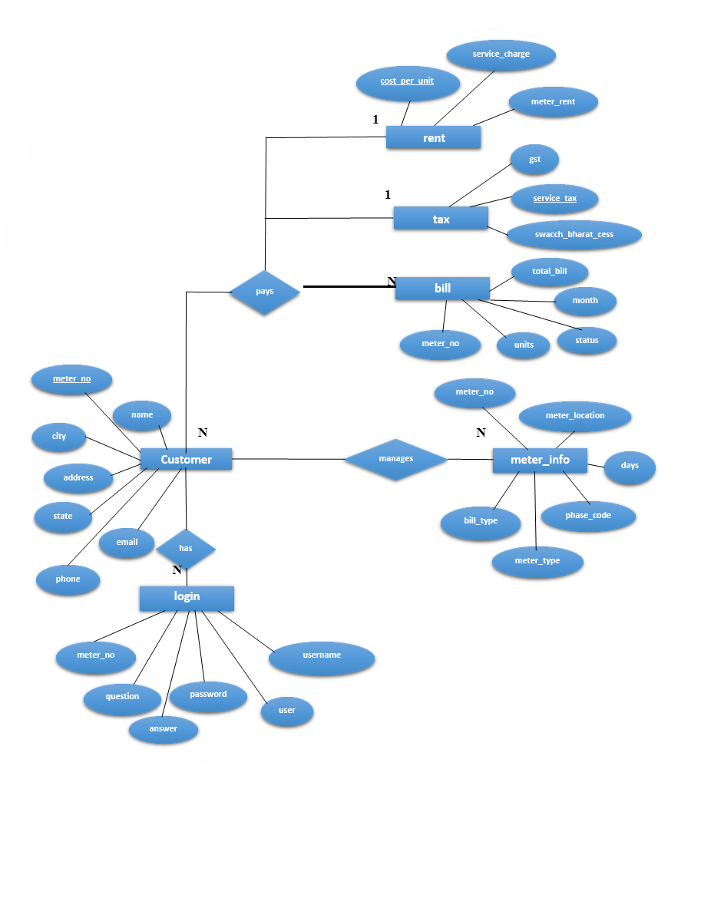







**ERD to Table Conversion**

**Login**

|  |  |  |  |  |  |
| --- | --- | --- | --- | --- | --- |
| Meter No | Username | Password | User | Question | Answer |

**Customer**

|  |  |  |  |  |  |  |
| --- | --- | --- | --- | --- | --- | --- |
| Name | Meter No | Address | City | State | Email | Phone |

**Rent**

**Tax**

**Bill**

**Meter Info**

|  |  |  |
| --- | --- | --- |
| Cost Per Unit | Meter Rent | Service Rent |

|  |  |  |
| --- | --- | --- |
| Service Tax | Swacch bharat cess | GST |

|  |  |  |  |  |
| --- | --- | --- | --- | --- |
| Meter No | Month | Units | Total Bill | Status |

|  |  |  |  |  |  |
| --- | --- | --- | --- | --- | --- |
| Meter No | Meter Location | Meter Type | Phase Code | Bill Type | Days |

**Schema Definitions/Table Creation:**

Schema definition of Electricity Billing System has six tables i.e., login, customer, tax, rent, bill, and meter_info where each table contain attributes some with primary key, foreign key.

TABLE login (meter_no INT PRIMARY KEY, username VARCHAR, password VARCHAR, user VARCHAR question VARCHAR, answer VARCHAR);

TABLE customer (name VARCHAR, meter_no INT PRIMARY KEY, address VARCHAR, city VARCHAR, state VARCHAR, email VARCHAR, phone VARCHAR);

TABLE rent (cost_per_unit INT PRIMARY KEY, meter_rent INTservice_charge INT);

TABLE tax (service_tax INTswacch_bharat_cess INTgst INT);

TABLE bill (meter_no INT, month VARCHAR, units INT, total_bill INTstatus VARCHAR, FOREIGN KEY (meter_no) REFERENCES customer(meter_no));

TABLE meter_info (meter_no INT, meter_location VARCHAR, meter_type VARCHAR, phase_code VARCHAR, bill_type VARCHAR, days INT, FOREIGN KEY (meter_no) REFERENCES customer(meter_no));

**H/w and S/w requirements:**

* **Software Requirements**
  + - Operating System: -Windows 10
    - Software: -Microsoft SQL Server
    - Front End: -Java core/swings (NetBeans)
    - Back End: -My SQL
* **Hardware Requirements**
  + - Hardware Specification: -Processor Intel Pentium V or higher
    - Clock Speed: -1.7 GHz or more
    - System Bus: -64 bits
    - RAM: -16GB
    - HDD: -2TB
    - Monitor: -LCD Monitor
    - Keyboard: -Standard keyboard
    - Mouse: -Compatible mouse

**References:**

#### Book Reference

Database Management Systems 3rd Edition by Raghu Ramakrishnan (TEXTBOOK).

* Samad, M. R., Islam, M. M., & Rahman, M. S. (2018). Development of an electricity billing system using ZigBee technology. International Journal of Computer Applications, 181(1), 25-29.
* Arumugam, R. (2014). Design and implementation of a prepaid electricity billing system using RFID. International Journal of Scientific and Research Publications, 4(2), 1-6.
* Zhu, Q. , Zhang, Y. , & Liao, H. (2013). An online electricity billing system for smart grid based on wireless sensor networks. Journal of Networks, 8(5), 1127-1134.
* Singh, H. , Bhagat, V. , & Saini, P. (2012). Design of electricity billing system using GSM technology. International Journal of Computer Applications, 40(1), 29-33.
* Alrasheedi, M. A. , & Shafie, A. A. (2011). The potential of smart grid in the audi Arabia electricity system. Renewable and Sustainable Energy Reviews, 15(1), 505-510.
* Zhu, Q. , Zhang, Y. , & Liao, H. (2013). An online electricity billing system for smart grid based on wireless sensor networks. Journal of Networks, 8(5), 1127-1134.

Singh, H. , Bhagat, V. , & Saini, P. (2012). Design of electricity billing system using GSM technology. International Journal of Computer Applications, 40(1), 29-33

Alrasheedi, M. A. , & Shafie, A. A. (2011). The potential of smart grid in the audi Arabia electricity system. Renewable and Sustainable Energy Reviews, 15(1), 505-510.

**Subject Incharge**

**(Ms. Shoma S. Mitkari)**